**Insert School Logo**

**Semester One Examination 2019**

**Question/Answer Booklet**

**MATHEMATICS**

**METHODS UNIT 3**

**Section Two:**

**Calculator-assumed**

Student Name: _____________________________________

Teacher’s Name: _____________________________________

**Time allowed for this section**

Reading time before commencing work: ten minutes

Working time for paper: one hundred minutes

**Material required/recommended for this section**

**To be provided by the supervisor**

This Question/Answer booklet

Formula Sheet (retained from Section One)

**To be provided by the candidate**

Standard items: pens(blue/black preferred), pencils(including coloured), sharpener, correction tape/fluid, erasers, ruler, highlighters

Special Items: drawing instruments, templates, notes on two unfolded sheets of A4 paper, and up to three calculators approved for use in the WACE examinations.

**Important note to candidates**

No other items may be taken into the examination room. It is **your** responsibility to ensure that you do not have any unauthorised notes or other items of a non-personal nature in the examination room. If you have any unauthorised material with you, hand it to the supervisor **before** reading any further.

**Structure of this paper**

|  |  |  |  |  |  |
| --- | --- | --- | --- | --- | --- |
|  | Number of questions available | Number of questions to be attempted | Working time (minutes) | Marks available | Percentage of exam |
| Section One  Calculator—free | 9 | 9 | 50 | 50 | 35 |
| **Section Two**  **Calculator—assumed** | **15** | **15** | **100** | **100** | **65** |
|  | | | |  | 100 |

**Instructions to candidates**

1. The rules for the conduct of Western Australian external examinations are detailed in the *Year 12 Information Handbook 2019.* Sitting this examination implies that you agree to abide by these rules.
2. Answer the questions according to the following instructions.

Section Two: Write answers in this Question/Answer Booklet. Answer **all** questions.

**Show all your working clearly.** Your working should be in sufficient detail to allow your

answers to be checked readily and for marks to be awarded for reasoning. Incorrect

answers given without supporting reasoning cannot be allocated any marks. For any

question or part question worth more than two marks, valid working or justification is required to receive full marks. If you repeat an answer to any question, ensure that you cancel the answer you do not wish to have marked.

It is recommended that you **do not use pencil**, except in diagrams.

1. You must be careful to confine your responses to the specific questions asked and to follow any instructions that are specific to a particular question.
2. Spare pages are included at the end of this booklet. They can be used for planning your responses and/or as additional space if required to continue an answer.

* Planning: If you use the spare pages for planning, indicate this clearly at the top of the page.
* Continuing an answer: If you need to use the space to continue an answer, indicate in the original answer space where the answer is continued, i.e. give the page number. Fill in the number of the question that you are continuing to answer at the top of the page.

1. The Formula Sheet is **not** handed in with your Question/Answer Booklet.

# Section Two: Calculator–Assumed 100 marks

This section has **fifteen (15)** questions. Attempt **all** questions. Write your answers in the spaces provided.

Spare pages are included at the end of this booklet. They can be used for planning your responses and/or as additional space if required to continue an answer.

* Planning: If you use the spare pages for planning, indicate this clearly at the top of the page.
* Continuing an answer: If you need to use the space to continue an answer, indicate in the

original answer space where the answer is continued, i.e. give the page number. Fill in the

number of the question(s) that you are continuing to answer at the top of the page.

Working time: 100 minutes

**Question 10 (6 marks)**

A circular drop of ink on blotting paper spreads from an initial area of 1 cm2 in such a way that if the radius is *r* cm after *t* seconds, then *r* = 3 *t* + 1.

(a) Show that the area of ink, *A* (in cm2), as a function of time is given by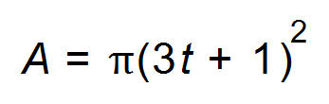.

(1)

(b) What is the rate of change of radius with time? (1)

(c) What is the exact rate of change of area with time when *t* = 1? (1)

(d) If the radius changes from 4 to 4.05 cm, use the incremental formula to find the

exact corresponding change in the area. (3)

**Question 11 (7 marks)**

Grace, a quality controller in a factory, obtained data from the last 322 production runs and found the following relationship.

If *X* is the number of defective items in a production run then:

P(*X* = 0) = P(*X* = 1)

P(*X* = 2) = 2P(*X* = 1)

P(*X* = 3) = 1.5P(*X* = 2)

P(*X* = 4) = 3P(*X* = 1)

P(*X* = 5) = 2P(*X* = 2)

(a) Complete the probability distribution and frequency table for the number of defective items in a production run. (4)

|  |  |  |  |  |  |  |
| --- | --- | --- | --- | --- | --- | --- |
| *X* | 0 | 1 | 2 | 3 | 4 | 5 |
| P(*X* = *x*) |  |  |  |  |  |  |
| Frequency |  |  |  |  |  |  |

(b) State the mode and the mean of the distribution. (2)

(c) What is the probability that 2 or 3 items are defective in a run? (1)

**Question 12 (6 marks)**

(a) Draw a graph which satisfies all the conditions listed below. Label the critical features clearly.

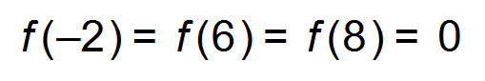

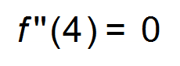and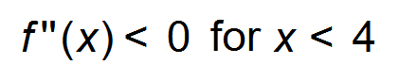only

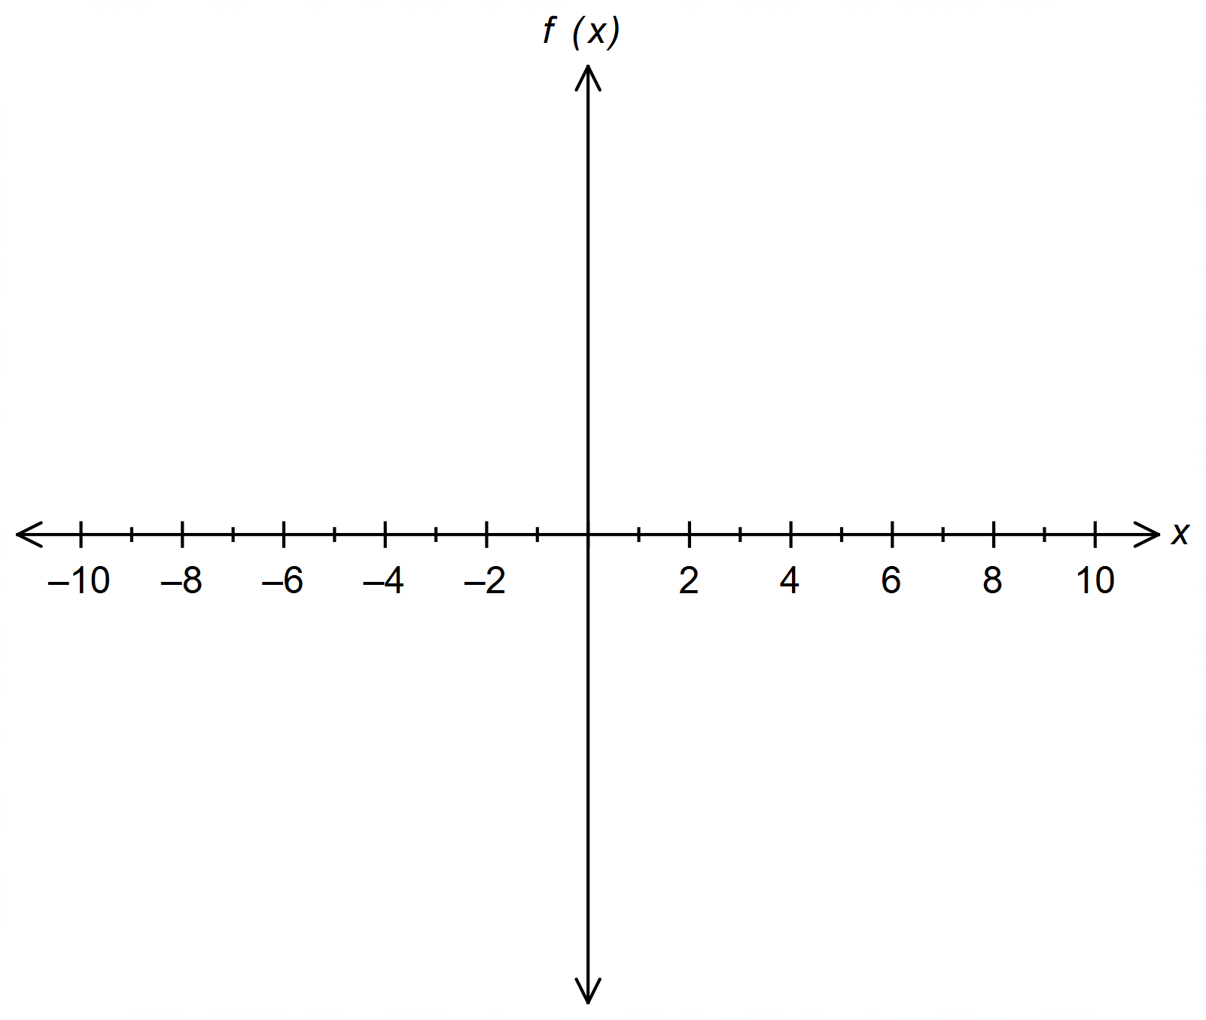 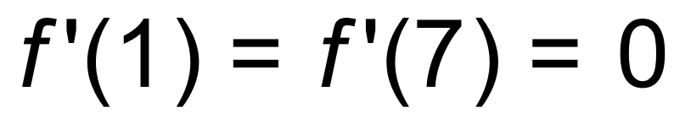 (3)

(b) The graph of the gradient function is shown below.

On the same set of axes sketch a possible graph of its anti-derivative. (2)

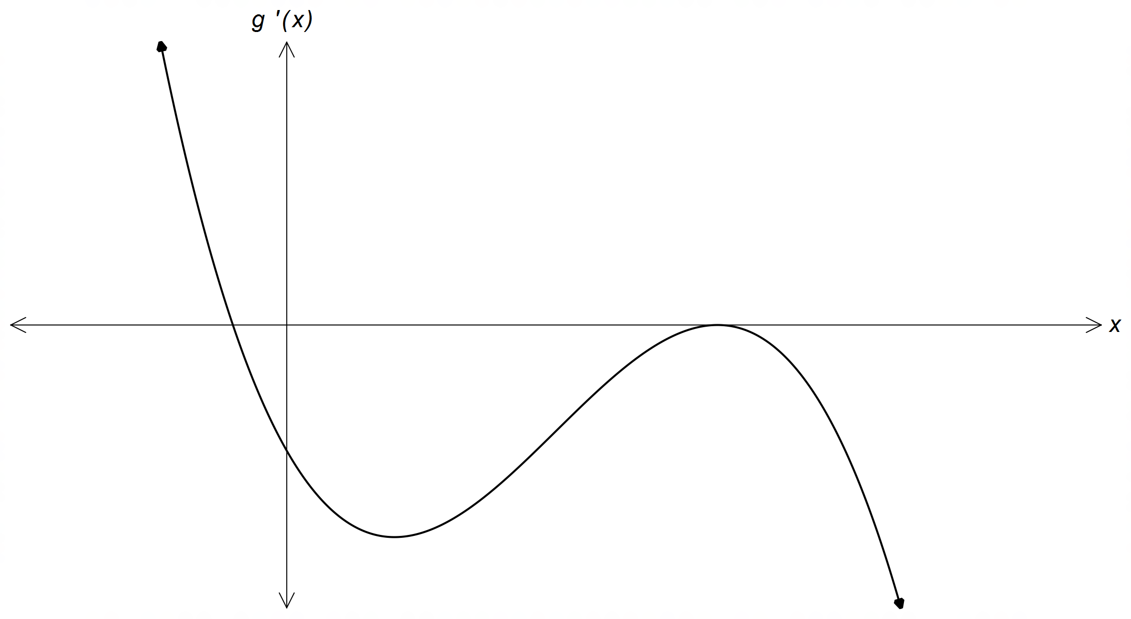

(c) Determine 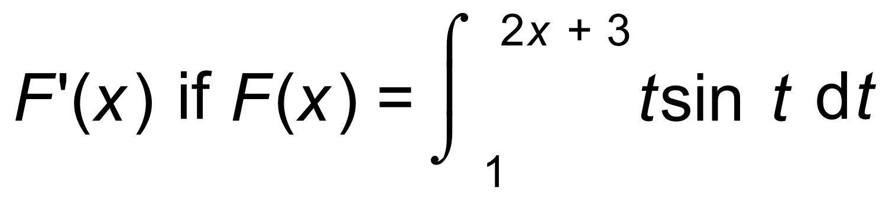 (1)

**Question 13 (6 marks)**

(a) Given that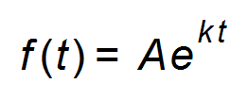, then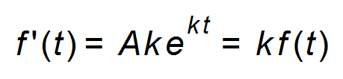.

The numbers in a colony of ants are observed to be growing at a rate of 2 ants per day

per 50 ants in the colony. How long does it take for the colony to double itself? (3)

(b) A bush fire near Esperance at time *t* hours is spreading at the rate of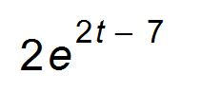m2/hour.

(i) What area is burnt out in the first 8 hours? (1)

(ii) What area is burnt out during the 10th hour? (1)

(iii) Explain why this function is an unrealistic model for *t* > 10. (1)

**Question 14 (5 marks)**

A particle moves in a straight line so that *t* seconds after passing through a point O it is

*s*(*t*) cm from O, where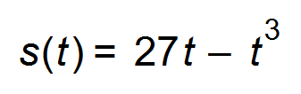.

Prove that the particle:

(a) moves away from O for the first 3 seconds. (2)

and then:

(b) returns to O reaching it with a speed of 54 cm/s. (3)

**Question 15 (3 marks)**

Find the function A(t) given that A(t) =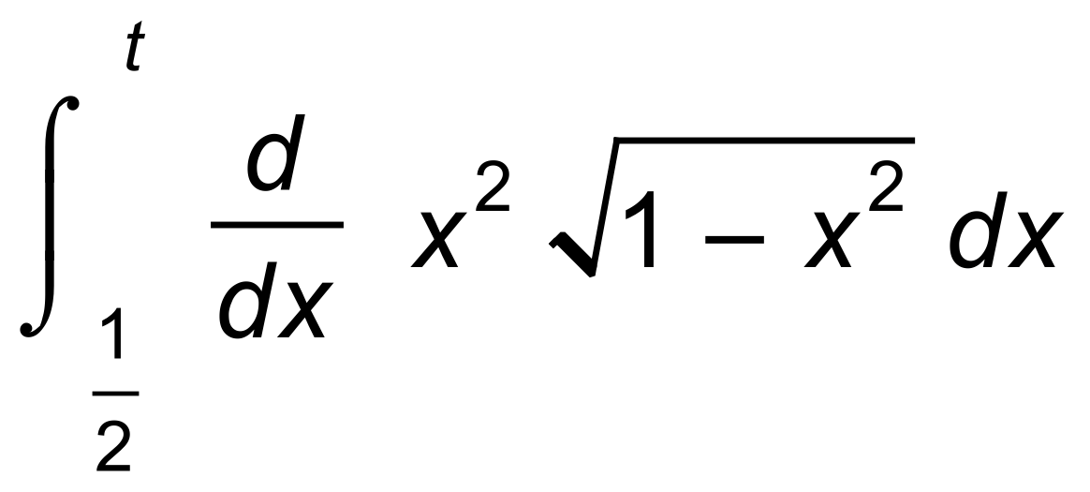. (3)

**Question 16 (6 marks)**

A local producer grows and sells organic figs. The costs involved amount to $50 plus 80c per fig.

The producer estimates that if he charges $*r* for each fig, he will sell *n* figs where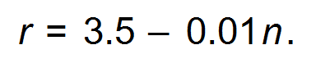

(a) If $*P* is the total profit from selling *n* figs, show that *P* = 2.7*n* − 0.01*n*2 − 50. (2)

(b) If the producer charges $2.50 per fig, how many will he sell **and** what will the

marginal profit be?

(4)

**Question 17 (10 marks)**

(a) From a group of five women and three men, three persons are selected to form a committee.

Let Y be the number of women on the committee.

(i) Complete the probability distribution table. (2)

|  |  |  |  |  |
| --- | --- | --- | --- | --- |
| Y | 0 | 1 | 2 | 3 |
| P(Y = *y*) |  |  |  |  |

(ii) Determine the expected value and variance of the distribution. (2)

(iii) What is the probability of two men being on the committee? (1)

(b) Sahin notes that in an industrial area, 70% of business owners have an electric fence on the perimeter of their property.

(i) Find the probability that in a random sample of ten properties in this area,

seven of them have an electric fence. (1)

(ii) Find the probability that in a random sample of twenty six properties,

at most half of them have an electric fence. (1)

(c) A binomial distribution has a variance of 9 and an expected value of 12.

Find *n* and *p*. (3)

**Question 18 (8 marks)**

Water flows into a town reservoir at a rate of *f*(*t*) megalitres per day. To supply the needs of the town, water flows out at the rate of *w*(*t*) megalitres per day.

(a) Explain why neither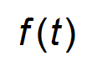nor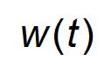can be negative, although each function could be

equal to zero for a certain time. (2)

(b) Write an expression for the rate of change of the total quantity of water in the reservoir. (1)

(c) Write a definite integral to represent the total amount of water flowing in to the

reservoir from time *t*0 to *t*1. (1)

(d) If the functions are modelled such that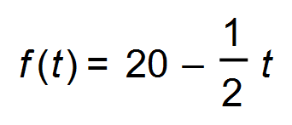 and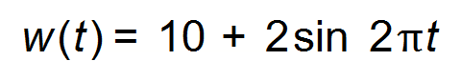,

find the total change in the volume of water in the reservoir during the first 30 days. (2)

(e) Label the functions and show your solution to (d) below. (2)

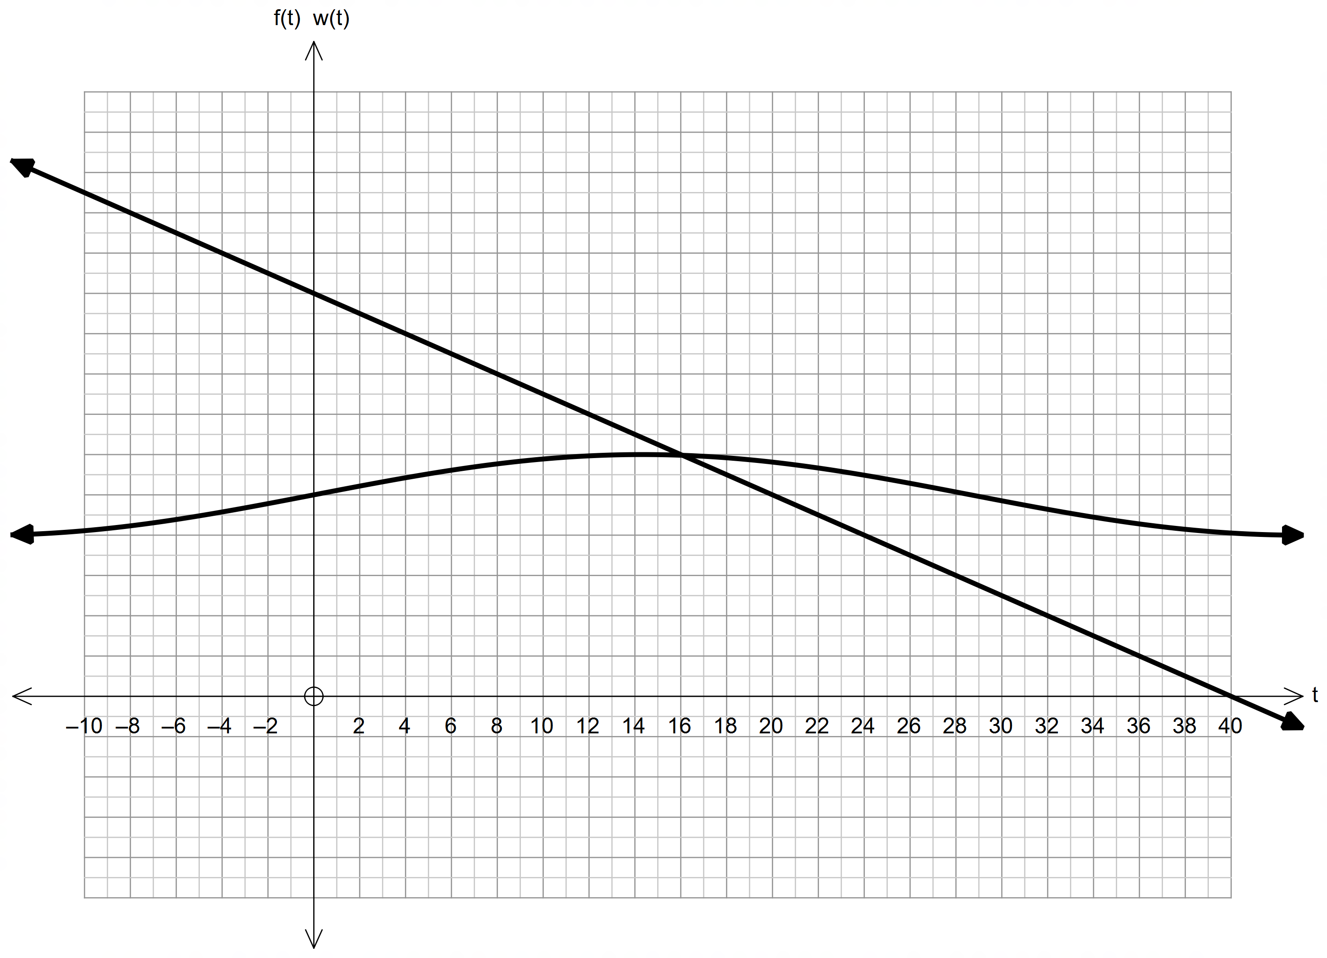

**Question 19 (12 marks)**

(a) At a recycle centre, washing machines are separated into two piles; machines that work

and machines that are broken. The probability that a washing machine works is 0.2

(i) Explain how each machine can be considered a Bernoulli trial. (2)

(ii) Find the expected value and the standard deviation for the probability of a

washing machine still working at the recycle centre. (2)

(b) The probability of a mobile phone being defective is 0.03. A quality controller selects

mobile phones from a termination point. When a defective mobile phone is found the

controller puts the mobile phone to one side and starts the inspection process again.

Let *X* be the number of *non-defective* mobile phones selected before a defective

mobile phone is found.

(i) Describe the meaning and then determine P(*X* = 0). (2)

(ii) Describe the meaning and then determine P(*X* = 2). (2)

(iii) Find the probability that if six mobile phones are selected, the last one

is the first defective one. (2)

(iv) Find the probability that at least three non−defective mobile phones will

be selected before a defective mobile phone is found. (2)

**Question 20 (9 marks)**

(a) Show that the total area enclosed between the curve 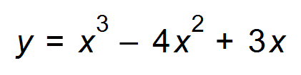

and the *x* – axis is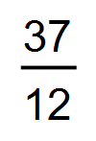units2. (3)

(b) The second derivative of a function is given by 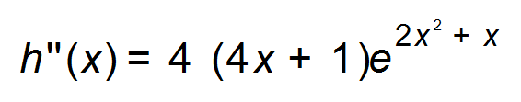.

If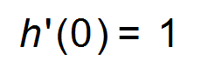, show that the exact gradient of the tangent to the curve where

*x* = 1 is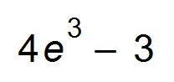. (3)

(c) Find the area enclosed by the graphs of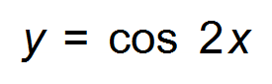and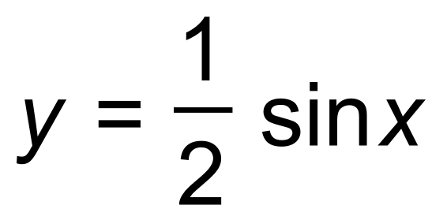

between *x* = 0 and *x =* π. (3)

**Question 21 (5 marks)**

Use calculus methods to find the maximum area of a triangle whose sides are 15, 15 and 2*x* cm.

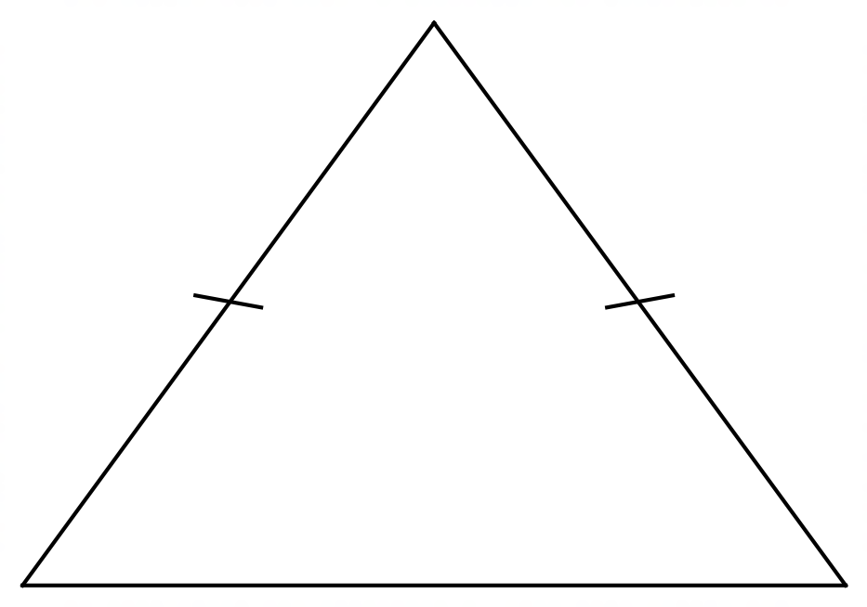

(Hint: Let the height of the triangle be *h*.)

**Question 22 (5 marks)**

The acceleration, *a*(*t*) m/s2, of a particle at time *t* seconds is given by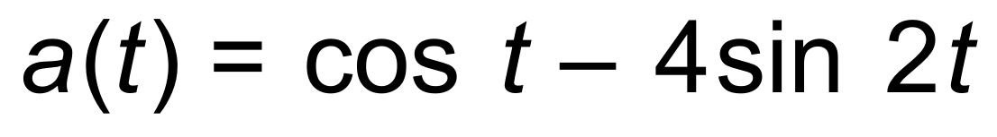

where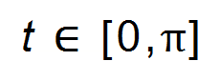. The velocity of the particle at *t* = 0 is 2 m/s.

(a) Find when the particle changes direction. (3)

(b) Find the total distance the particle travelled during the given time interval. (2)

**Question 23 (5 marks)**

The graph of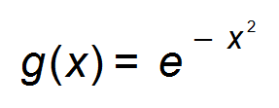is shown below. Complete the table (round to two decimal places) and then use rectangles from the left and the right to estimate the area under the graph of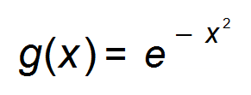from 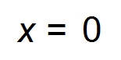 to 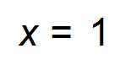 by dividing the region into 5 equal strips. (4)

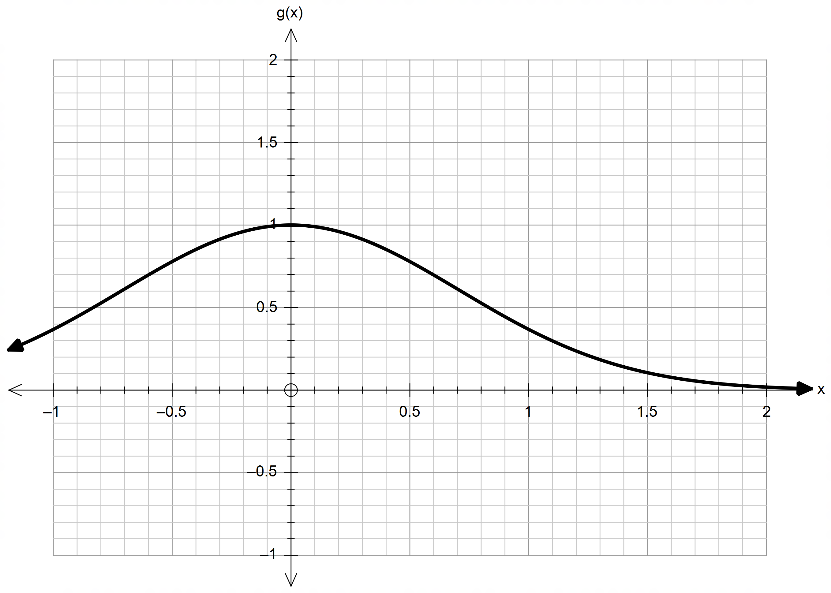

|  |  |  |  |  |  |
| --- | --- | --- | --- | --- | --- |
| *g*(0) | *g*(0.2) | *g*(0.4) | *g*(0.6) | *g*(0.8) | *g*(1) |
|  |  |  |  |  |  |

(b) Explain how the area is affected as the width of the rectangle tends to 0. (1)

**Question 24 (7 marks)**

Marie Curie, a French – Polish physicist and chemist, was the first woman to win a Nobel Prize, the first person and only woman to win twice, and the only person to win a Nobel Prize in two different sciences. In 1909, she succeeded in isolating 1 gram of pure radium. The decay function of radium is approximately 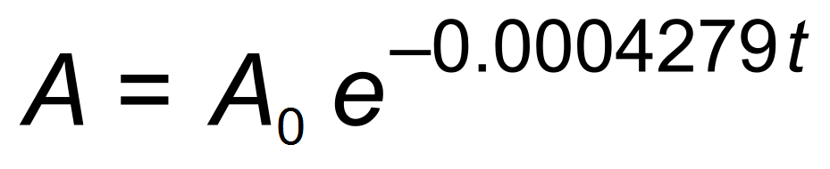 where *t* is time in years.

(a) What percentage of that 1 gram of radium will have decayed by now (2019)? (2)

(b) Based on the above information, what is the half-life of radium? (2)

(c) Radon, a radioactive gas, is one of the products of the decay of radium.

The half-life of radon is 3.8 days.

If there is 10 mg of radon gas at *t* = 0, how much will there be 15 days later? (3)

**END OF QUESTIONS**

**Additional working space**

Question number(s): ……………………

**Additional working space**

Question number(s): ……………………

**Additional working space**

Question number(s): ……………………

WATP acknowledges the permission of the School Curriculum and Assessment Authority in providing instructions to students.